Module 1

What is a Program?
1. Write a simple "Hello World" program in two different programming languages of
your choice. Compare the structure and syntax.

- In c language:-
#include<stdio.h>
int main(){

printf("Hello World")

}

- In python language:-

print("Hello World")

World Wide Web & How Internet Works
2. Research and create a diagram of how data is transmitted from a client to a server over the internet
over the internet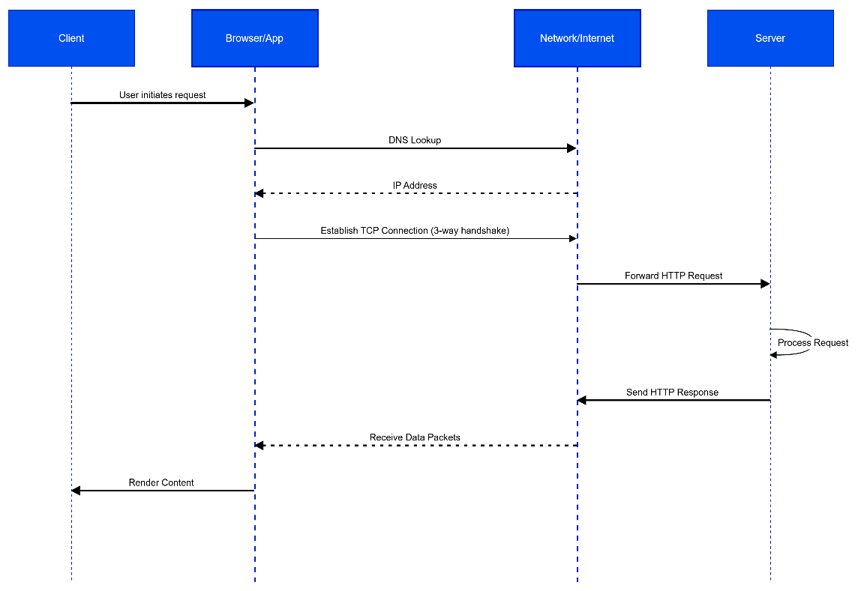

Network Layers on Client and Server
3. Design a simple HTTP client-server communication in any language.

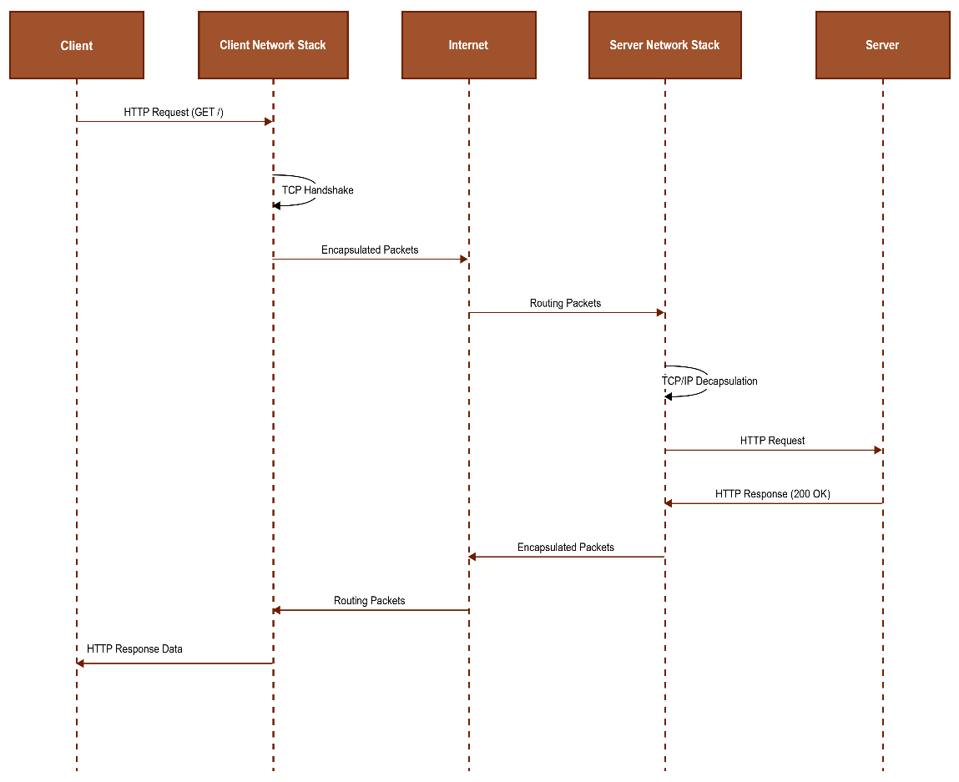

Types of Internet Connections
4. Research different types of internet connections (e.g., broadband, fiber, satellite)and list their pros and cons.
- Types of Internet Connections
🔹 1. Dial-Up Connection
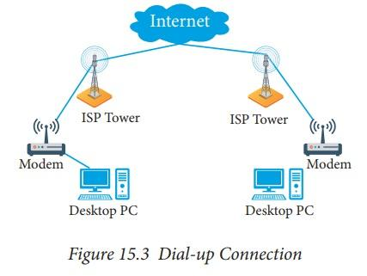
Description:
Uses telephone lines and a modem to connect to the internet.
Pros:
- Very low cost
- Available in remote areas
Cons:
- Very slow speed (up to 56 kbps)
- Cannot use phone and internet at same time
- Outdated technology
🔹 2. Broadband (DSL/Cable):

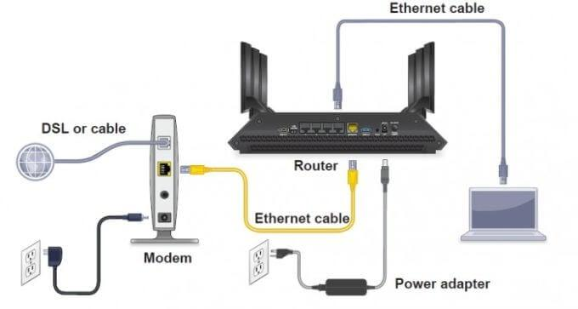
Description:
High-speed internet using telephone (DSL) or cable TV lines.
Pros:
- Faster than dial-up
- Always-on connection
- Affordable and widely available
Cons:
- Speed depends on location
- Shared bandwidth may slow down
🔹 3. Fiber Optic Connection:
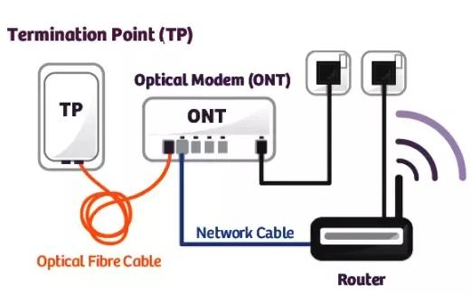
Description:
Uses light signals through fiber optic cables for very high-speed internet.
Pros:
- Extremely high speed (Gbps)
- Reliable and low latency
- Best for streaming, gaming, and cloud
Cons:
- Expensive installation
- Limited availability in some areas
🔹 4. Satellite Internet:

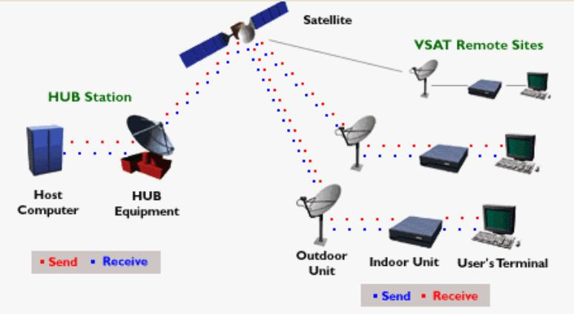
Description:
Internet provided via satellites in space.
Pros:
- Works in remote and rural areas
- Wide coverage
Cons:
- High latency (delay)
- Expensive
- Weather can affect signal
🔹 5. Mobile Data (3G / 4G / 5G):



Description:
Wireless internet through mobile networks.
Pros:
- Portable and easy to use
- No wires required
- Widely available
Cons:
- Data limits (plans)
- Speed varies with signal
- Can be costly for heavy use

🔹 6. Wi-Fi (Wireless Internet):

Description:
Wireless access to internet using a router (usually connected to broadband/fiber).
Pros:
- Connect multiple devices
- No cables needed
- Convenient for home and office
Cons:
- Limited range
- Security risks if not protected
- Speed depends on router and connection

Protocols
5.Simulate HTTP and FTP requests using command line tools (e.g., curl).

- Title:
Simulate HTTP and FTP Requests Using Command Line Tool (curl)

Objective:
To simulate HTTP and FTP requests using the curl command and understand how data is transferred between client and server.

Requirements:
- Computer system
- Command Prompt / Terminal
- curl tool

Theory:
curl is a command-line tool used to send and receive data using various protocols such as HTTP and FTP.
It acts as a client and communicates with servers to request or transfer data.

Procedure:
1. Open Command Prompt or Terminal.
2. To simulate HTTP request, type:
curl http://example.com
3. Press Enter and observe the output.
4. To view only HTTP headers, type:
curl -I http://example.com
5. Press Enter and observe the response headers.
6. To simulate FTP request, type:
curl ftp://speedtest.tele2.net
7. Press Enter to view list of files on FTP server.
8. To download a file using FTP, type:
curl -O ftp://speedtest.tele2.net/1MB.zip
9. Press Enter and observe file download.

Observation:
- HTTP request returns webpage data or headers.
- FTP request shows file list or downloads files.
- curl works as a client to communicate with servers.

Result:
Successfully simulated HTTP and FTP requests using curl command
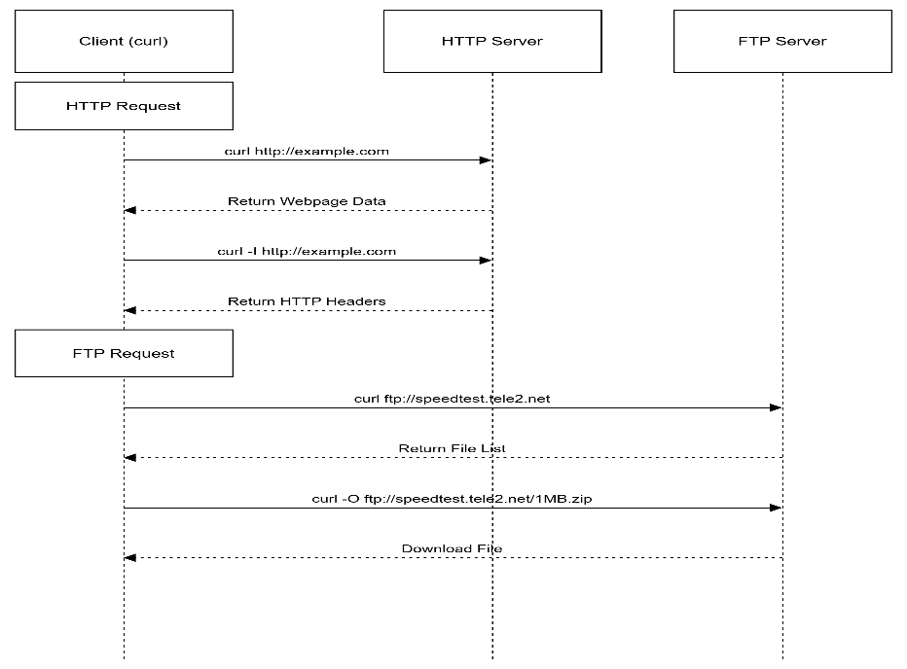

Application Security
6. Identify and explain three common application security vulnerabilities. Suggestpossible solutions.

